Assessment Schedule – 2013

Calculus: Apply the algebra of complex numbers in solving problems (91577)

Assessment Criteria
Achievement | Merit | Excellence
Apply the algebra of complex numbers in solving problems  must involve:  - using a range of appropriate algebraic methods  - demonstrating knowledge of concepts and terms  - and communicating using appropriate representations. | Apply the algebra of complex numbers, using relational thinking, in solving problems  must involve one or more of:  - carrying out a logical sequence of steps  - connecting different concepts and representations  - demonstrating understanding of concepts  - forming and using a model  - and relating findings to a context, or communicating thinking using appropriate mathematical statements. | Apply the algebra of complex numbers, using extended abstract thinking, in solving problems  must involve one or more of:  - devising a strategy to investigate or solve problem  - identifying relevant concepts in context  - developing a chain of logical reasoning, or proof  - forming a generalisation  - and using correct mathematical statements, or communicating mathematical insight.

Evidence Statement

One | Expected Coverage | Achievement  (u) | Merit  (r) | Excellence  (t)
(a) | 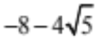 | Or equivalent.
(b) | 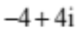 clearly marked on Argand diagram. | Must plot point.
(c) | 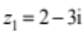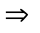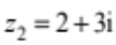  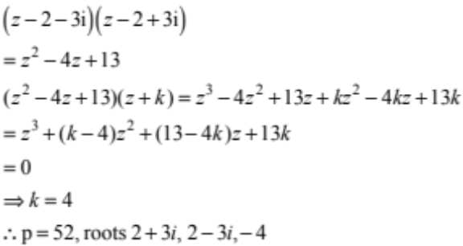 | Either  one other root found  or  p = 52 | Both other roots and p found.  CRO
(d) | 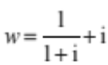  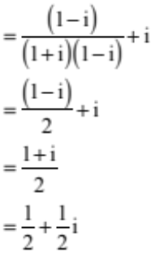  Arg (w) = 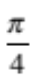 or 45° | Simplified expression for w  or  Arg (w) = 0.785 | Exact value of argument found.  CRO.

One | Expected Coverage | Achievement  (u) | Merit  (r) | Excellence  (t)
(e) | 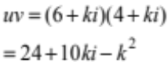  Arg = Re(uv) = Im(uv)  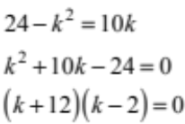  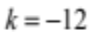 or 2  k = –12 uv = –120 – 120i  Arg = 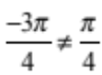   k = 2 uv = 20 + 20i  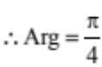  k = 2 | Expanded expression for uv.  CRO | Two correct solutions for k from quadratic equation. | Correct answer  (k = 2) with a logical chain of reasoning.

NØ = No relevant evidence A3 = 2 u M5 = 1 r E7 = 1 t with 1 minor error
N1 = 1 partial solution A4 = 3 u M6 = 2 r E8 = 1 t
N2 = 1 u

Two | Expected Coverage | Achievement  (u) | Merit  (r) | Excellence  (t)
(a) | –7 | Remainder found.
(b) | 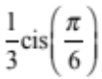 | Or equivalent.
(c) | 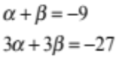  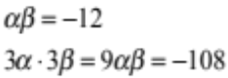  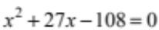 | Two correct terms out of  x², 27x or –108. | A correct equation.
(d) | 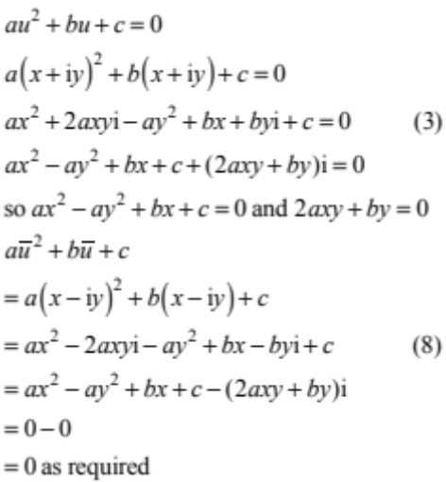 | Expanded expression for equation in terms of x and y (ie 3rd line). | Proof correct with logical mathematical statements.
(e) | 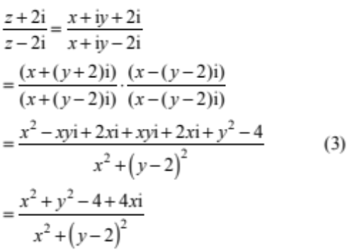  As purely imaginary, the real part equals zero.  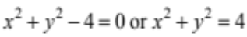  Locus is a circle, radius 2, centred at (0,0).  [excludes the point (0,2)] | CRO | Expanded expression with correct numerator or denominator.  (ie 3rd line). | Correct answer with a logical chain of reasoning.  Do not have to check when denominator equal to zero to find exclusion.

NØ = No relevant evidence A3 = 2 u M5 = 1 r E7 = 1 t with 1 minor error
N1 = 1 partial solution A4 = 3 u M6 = 2 r E8 = 1 t
N2 = 1 u

Three | Expected Coverage | Achievement  (u) | Merit  (r) | Excellence  (t)
(a) | 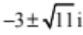 | Simplified solutions.
(b) | 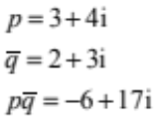 | Simplified solution.
(c) | 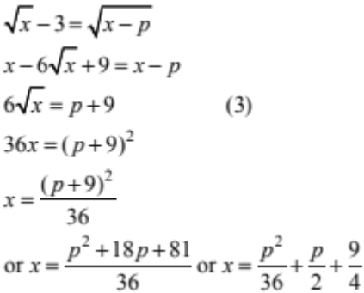 | Correct expression with x’s eliminated  (ie 3rd line). | Or equivalent.
(d) | 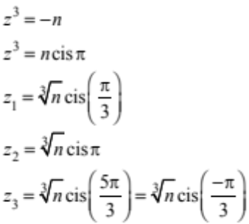  Accept arguments in decimal radians:  1.047, 3.142, 5.236 or –1.047  Accept arguments in degrees:  60°, 180°, 300° or – 60° | ONE correct solution. | THREE correct solutions.
(e) | 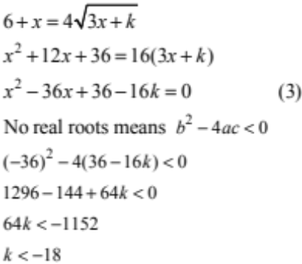 | CRO | Simplified quadratic expression  (3rd line). | Correct answer with a logical chain of reasoning.

NØ = No relevant evidence A3 = 2 u M5 = 1 r E7 = 1 t with 1 minor error
N1 = 1 partial solution A4 = 3 u M6 = 2 r E8 = 1 t
N2 = 1 u

Judgement Statement
 | Not Achieved | Achievement | Achievement  with Merit | Achievement  with Excellence
Score range | 0 – 7 | 8 – 12 | 13 – 18 | 19 – 24

